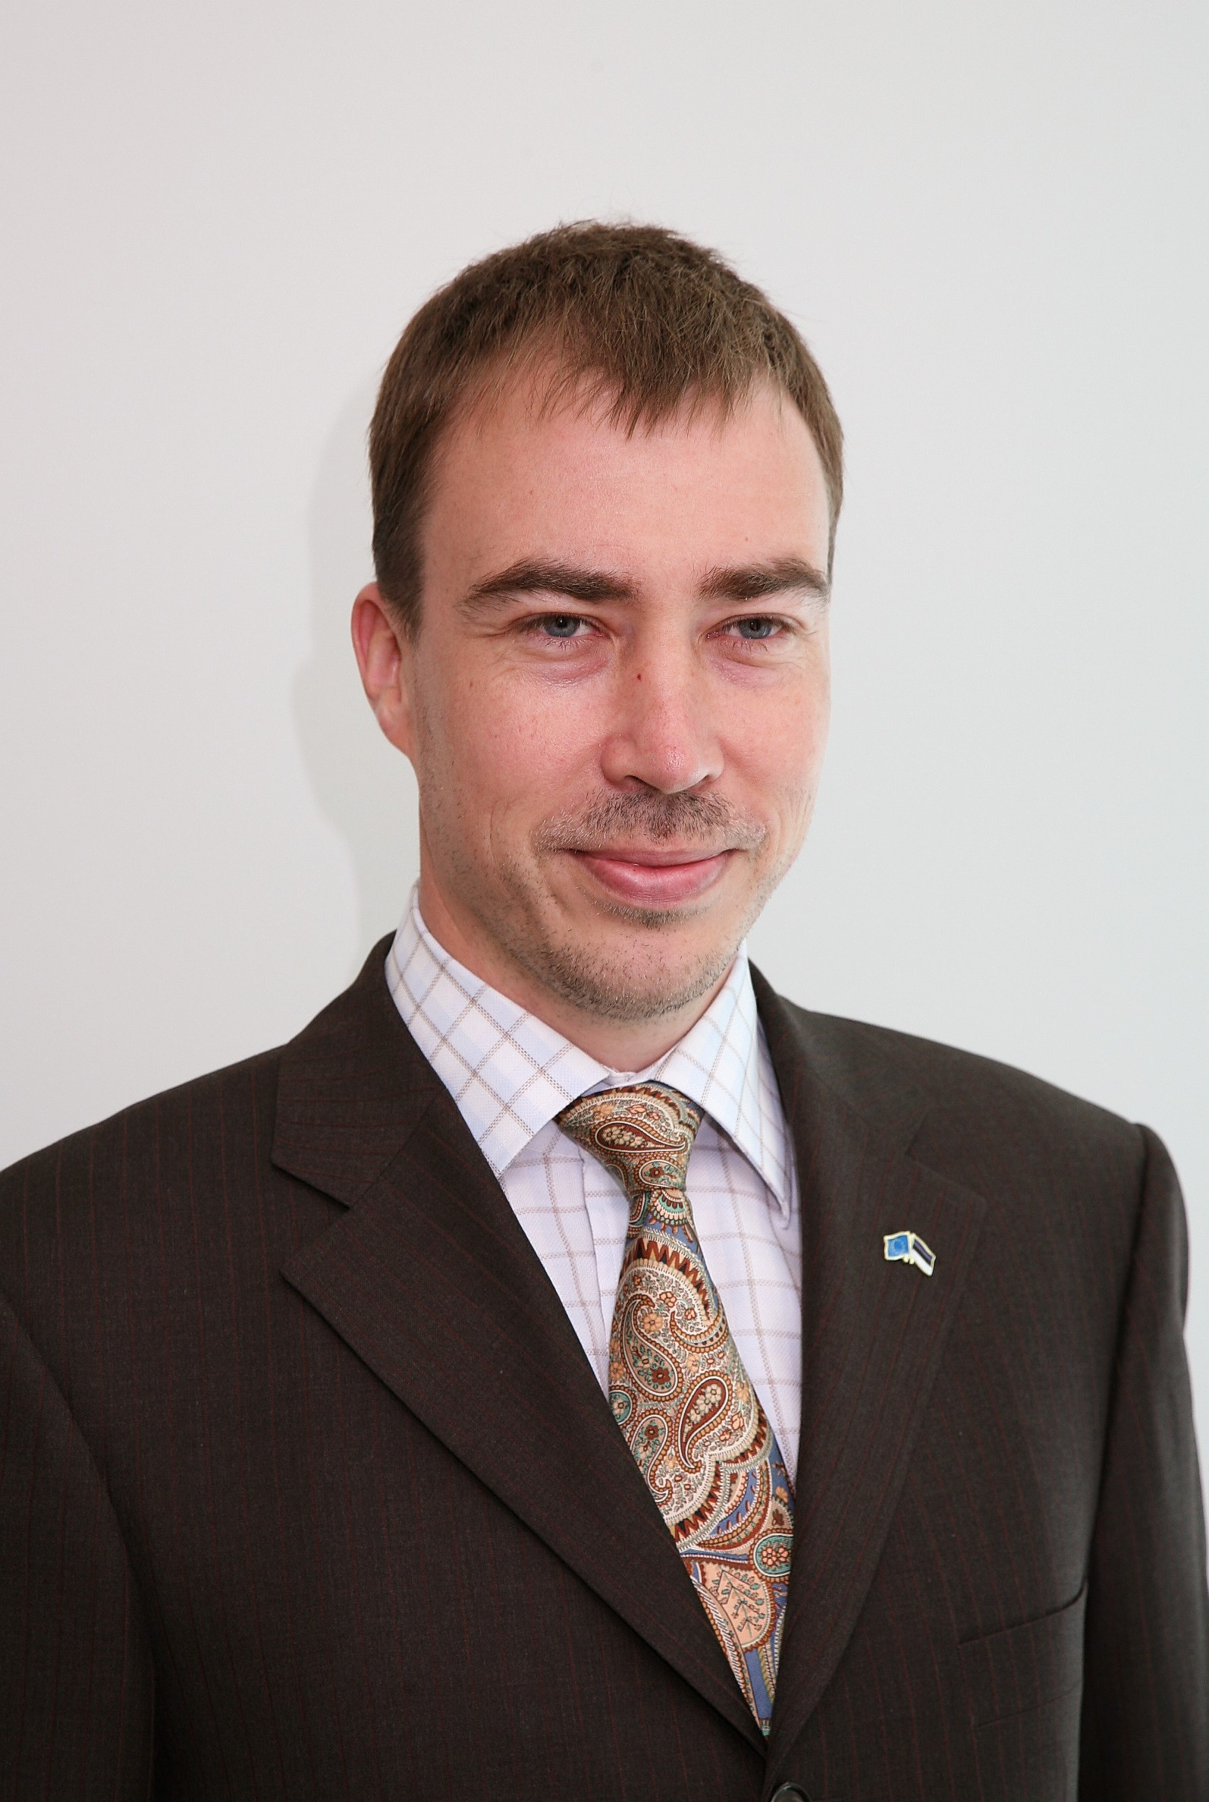
Toivo Klaar
Head of Mission for the EU Monitoring Mission in Georgia (EUMM Georgia)

Mr Toivo Klaar was appointed Head of Mission for the EU Monitoring Mission in Georgia (EUMM Georgia) on 13 September 2013. Previously, from March 2012, he was Head of Division for Human Resources Policy and Coordination in the European External Action Service (EEAS). Prior to this, he was Head of Division for Resources and Planning in the EEAS and Head of Unit for Reform and Staff Resources of DG Relex of the European Commission, which was responsible for the management of the creation of the EEAS.

Prior to joining DG Relex he served as the first head of the European Commission Representation in Estonia from 2005 to 2010.

Before this he held various positions in the Estonian civil service, including Foreign Policy Advisor to President Lennart Meri, Director General for Political Affairs and Director General for EU Affairs in the Foreign Ministry and Advisor to the Minister of Defence.
Mr. Klaar holds a Master of Public Administration degree from Harvard University’s John F. Kennedy School of Government.

He is married to Heli Tiirmaa-Klaar and they have a son and daughter.

Chronological CV:
2013- Head of EUMM Georgia
2012-2013 Head of Division for HR Policy and Coordination, EEAS
2011-2012 Head of Division for Resources and Planning, EEAS
2010-2011 Head of Unit for Reform and Staff Resources, DG Relex
2005-2010 Head of European Commission Representation in Estonia
2003-2005 Advisor to the Minister of Defence of Estonia
2003-2004 Consultant to Bulgarian government on public administration reform
2002-2003 Masters studies at Harvard
2001-2002 Defence Counsellor, Embassy of Estonia in Washington, DC
1999-2001 Foreign Policy Advisor to President Lennart Meri (seconded from MFA)
1998 Director General of EU Department, MFA
1995-1998 Deputy Head of Mission, Estonian Embassy Brussels
- accredited to EU, NATO, WEU, as well as BE, NL and LUX
1992-1994 Director General for Political Affairs, MFA
1992 Head of Estonian Delegation to CSCE Follow-up Meeting in Helsinki
1991 Assistant to the Minister of Foreign Affairs

